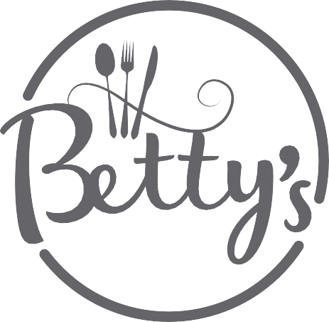
Menu
Try Something Different with our Sharing Bowls £4 each or 3 for £10
Nachos topped with Salsa and Cheese, Onion Rings, Chicken Fillets, Haddock Goujons, Dirty Fries, Chilli Bowl

Or Try Our Sharing Boards £8.95
Cheese Board, With Grapes, Chutney and oatcakes.
Charcuterie Board Select Cured Meats with Olives and Bread

Soup of The Day £3.75
Served with Fresh Bread and butter (Vegan Option Available)
Sandwich of the Day (Please ask your server) £6.50
Served with Crisps, Salad and Coleslaw add a hot bowl of soup for £1
Curry of the Week (Please ask your server) £9.00
Served with rice
Salad of the Day £7.50
Freshly Prepared Salad by our Chefs
Betty’s Burger and Chips £8.50
Served with Lettuce a Slice of Mature Cheddar, tomato and Relish,
choose from Chicken, Beef or our Vegan Beetroot Burger! Add Bacon or Chilli for £1.50
Macaroni Cheese £8.50
Served with Salad, Garlic Bread and Chips. (Add; Black pudding, Bacon, Chorizo, Wild Mushrooms for an extra £1)
Fish and Chips £9.95
Breaded or Battered, Served with Chips, Tartare Sauce and Peas
Scampi £9.00
Served with Chips, Tartare Sauce and Peas
Steak Pie £9.95
Served with Seasonal Vegetables and either chips or potatoes
Crispy Battered Chicken Goujons £8.50
Crispy coated Chicken, served with chips, salad and a BBQ dip

Please let your server know of any allergens or intolerances

